This Board Charter sets out the role, responsibilities, structure and processes of the Board of Directors (the “Board”) of Westernport Region Water Corporation, trading as Westernport Water (WPW) (the “Corporation”).

- Legislative Context
  - Westernport Water is constituted under the Water Act 1989 and managed through the Department of Environment, Land, Water and Planning.
  - Although owned by the government, Westernport Water acts as stand-alone entity and is responsible for its own management and performance.
  - Under the State’s laws, the Board of each water business reports to the Minister for Water (the “Minister”) via the Department of Environment, Land, Water and Planning (DELWP). In turn, the Minister is responsible for reporting to Parliament on the performance of each water business.
  - The Water Act 1989 (Vic) and the Public Administration Act 2004 establish the relationship between the Minister and the Corporation under which the Minister has the power to:
    - Regulate aspects of water management;
    - Request regular reports and information;
    - Make Policy;
    - Issue Ministerial Directions;
    - Set Standards and Obligations.

  - In addition to complying with the legislative provisions, the Corporation needs to ensure that it maintains a good relationship with the Minister, keeping them well-informed of all critical issues.

  - As well as reporting directly to the Minister, the Corporation has a responsibility to report to and take direction from the following entities:

Government Entity | Area of Regulation
Treasurer (Department of Treasury and Finance) | Financial management
Secretary to the Department of Health and Human Services | Safe drinking water
Essential Services Commission | Pricing & Performance
Environment Protection Agency | Environmental protection
Energy and Water Ombudsman (Victoria) | Customer dispute resolution

  - Collectively the Legislative Context including changes to Government and its structure, and the Instruments, Standing Directions, Instructions and Guidelines that are issued by the various Departments of Government are encapsulated in the term “Machinery of Government” in this Charter.

  - Westernport Water is governed by a Board of Directors (the “Board”), led by a Chair (the “Chair”) appointed by the Minister, and managed day-to-day by the Managing Director (the “MD”) under delegation from the Board. The Board is accountable to the Minister for the performance of Westernport Water.

  - The MD is a member of the Board and is the primary link between the Board and Westernport Water’s employees – providing organisational leadership, communicating Board priorities and policies to the employees and presenting reports, submissions and budgets to the Board.

The following image provides an overview of the various roles and responsibilities within the governing and operational context of Westernport Water.

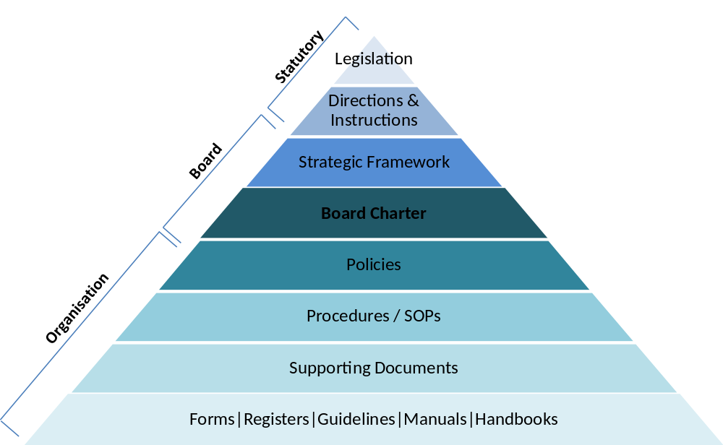

- Role of the Board
  - The role of the Board is, through effective corporate governance, to provide strategic guidance and leadership for the Corporation.
Transparency
How is evidence being provided to the Board of how compliance is being managed within the Organisation?
Accountability
Who is accountable for what?
Is there clarity of delegations?
Effective Corporate Governance
Corporate Control
Is the Board doing the right thing?

  - The Board has duty to act with care and diligence, work as a team, and meet on a regular basis, no less than once every three months.

  - The Board collectively, and each Director individually, has the right to seek independent professional advice on matters pertaining to governing the Corporation, subject to the approval of the Chair, or in the Chair’s absence, the Board. Upon receipt, the advice is circulated to all Directors. Other Directors should be advised of both an approval to seek independent advice and of any declined request for a Director to obtain advice.

- Responsibilities of the Board
The responsibilities of the Board are (but not limited to):
  - Governance, Compliance and Risk
    - Leading the strategic direction of the Corporation including the development with management of the corporate objectives, strategy and policy, approving plans, new investments, major capital and operating expenditures, and major funding activities proposed by management;
    - Understanding and protecting the Corporation’s financial position through approving annual targets and financial statements and monitoring actual financial performance against forecast and prior periods;
    - Providing oversight and monitoring the Corporation’s obligations set out within its governing legislation, including requiring and monitoring legal and regulatory compliance, compliance with accounting standards, unfair trading legislations, occupational health and safety, environmental standards and monitoring the health and wellbeing of the Corporation’s employees;
    - Considering and approving the Corporation’s frameworks for managing all categories of risk and monitoring the effectiveness of risk management, including satisfying itself through appropriate reporting and oversight that effective internal control mechanisms are in place and are being implemented in accordance with regulatory requirements;
    - Assessing and determining whether to accept risks beyond the approval discretion provided to management;
    - Attending to matters referred to it by the MD or Committees of the Board and to any matters identified through the Machinery of Government and as reserved by legislation or policy to the Board;
    - Protecting the reputation of the Corporation by being aware of and informing the other directors of any litigation, actions, transactions, issues, papers and reports to external/third parties which impact on the Corporation and may attract significant public, government, regulatory or other interest;
    - Assuring itself that appropriate audit arrangements are in place;
    - Unless requested to do so by the Chair, members of the Board other than the Chair and the MD may not comment publicly on the Corporation’s functions, performance or affairs of the Board. The Chair and the MD will confer and agree with each other before making a significant public comment. Copies of all significant press releases are forwarded to all Directors.

  - The Board and the Managing Director
The Act provides direction on terms relating to the appointment and removal of the MD, including that the Board is responsible for:
    - Subject to Government direction of the day recommend to the Minister the appointment of the MD;
    - Evaluating and assessing performance of, rewarding and if necessary the removal of the MD;
    - Determining the corporate goals and objectives relevant to the remuneration of the MD and evaluating the performance of the MD in light of these objectives;
    - Reviewing and approving succession plans for the MD, executives reporting to the MD and any other key personnel;
    - Approving individual remuneration levels for executives who report directly to the MD and any other person the Board determines;
    - Determining the size of bonus / incentive pools as part of the Corporation’s annual plan based on consideration of pre-determined business performance indicators and the financial soundness of the Corporation.

- Chair of the Board
  - The Minister appoints one of the Directors to be the Chair in accordance with the Water Act 1989.
  - The Chair represents the Board to the Minister and communicates the Board’s position.
  - The Chair presides at meetings of the Board.
  - The Chair ensures the Board has ready access to up-to-date copies of relevant legislation, policies and procedures.
  - The Board appoints a Deputy Chair who must act as Chair if the position is vacant or the Chair is unable, for any reason, to perform the duties of the office. While acting as Chair, the Deputy Chair has and may exercise all the powers, and must perform all the duties of the Chair.

- Board Committees
  - The Board has established Committees to assist the Board in exercising its authority, including the responsibilities set out in the Act.
  - The standing Board Committees are:
    - Audit and Risk Committee;
    - People, Remuneration and Governance Committee.
  - The Board may establish other standing Committees or ad hoc Committees from time to time to consider matters of special importance or to exercise the delegated authority of the Board.
  - The Act (s.122c) directs the Committees on meeting protocols and failure by a Committee to comply with rules made by the Board regarding the Committee’s proceedings may breach section 122C(2)(d)(iii) of The Act.
  - The Board will determine the Charters of standing and ad hoc Board Committees, which will set out the roles and responsibilities of each Committee.
  - Committee Charters are subservient to the Board Charter; i.e. the Board Charter is the overarching Charter that provides direction to the Board and Committees and each Committee must comply firstly with the Board Charter, and then with the Committee Charter. If in any case the Committee Charter is silent on any matter, the Board Charter presides. In any case of confusion or contradiction, the Board Charter presides.
  - The Board requires Committees provide the Board with unredacted minutes of the Committee meeting at the next Board meeting following the Committee meeting.
  - The Board will determine the membership and composition of Board Committees, having regard to workload, skills and experience, and any regulatory requirements.
  - Unless explicitly empowered by the Board, Committees cannot make decisions for or speak on behalf of the Board.
  - As a general principle, Directors who are not Committee members should not attend Committee meetings as "observers" other than when they are expressly invited to do so by the Committee or by the Committee Chair.
  - The Board will annually review the composition of the Board Committees, as per the Board calendar.

- Director Conduct
  - The Public Administration Act 2004 prescribes each Director, in conducting the business of the Board, to comply with the Victorian Public Sector Values and the Code of Conduct published by the Public Sector Standards Commissioner. In addition, DELWP has published A Governance Guide to the Victorian Water Industry, which is essential reading for every Director.
  - As a member of Westernport Water’s Board each Director has a duty to act with care and diligence and is expected to individually:
    - Exercise independent judgment to make decisions for a proper purpose;
    - Not have a material personal interest in the subject matter of any decision;
    - Take steps to inform themself on the subject matter of the decision to the extent they reasonably believe to be appropriate;
    - Reasonably believe the decision is in the best interests of the Corporation;
    - Keep confidential any information they obtain as a result of their position as a Director;
    - Observe “cabinet solidarity” once a decision is reached - the Board’s responsibilities are collective and, once decisions are made, directors must not advocate a position contrary to the established decision;
    - Recognise that their actions may reflect on the Corporation and their conduct must not be called into question or bring either themself or Westernport Water into disrepute;
    - Adhere to all codes of ethics, codes of conduct and standards of behaviour that apply to employees or officers of the Corporation.
  - The Board assesses independence of Directors annually through a Declaration of Private Interests by each Director.

- Board Processes
  - Westernport Water adopts processes outlined in the Water Act 1989 (s120-122A) and assumes the DELWP Guidance Notes for Meetings. The Board is expected to familiarise itself with these to support effective Board process.
  - A minimum attendance by each Director of 75% of all Board meetings is required unless good reason exists.

  - Board Meetings
    - The Chair is responsible for the conduct of all Board meetings. This includes being satisfied that the agendas are comprehensive, that all agenda items are appropriate and that recommendations fit within the broad strategic direction set by the Board.
    - Members of the Executive Team may be invited to attend Board meetings. Directors have access to the executive managers (direct reports to the MD) in relation to issues for which they are accountable. All such enquiries are to be made with the knowledge and consent of the MD.
    - The Board will regularly meet without executive management (“in camera”).
    - Board meetings must occur once every three months and may occur at other such frequency as determined by the Board. The Board may meet, adjourn and otherwise regulate its meetings as it thinks fit. Board meetings may occur:
    - At any location agreed to by the Board; or
    - By using any form of technology such as telephone conferencing or videoconferencing; or
    - By using a combination of the above.
    - A majority of Directors present at a meeting constitutes a quorum.
    - The agenda together with supporting papers are made available through the Board portal or/and via email not less than five (5) business days before the meeting to provide Directors with reasonable time to prepare for the meeting.
    - A Director is required to declare a conflict of interest that relates to an item on the agenda even if they have already declared it on their Declaration of Private Interests form.
    - The Board will delegate the task of recording the minutes of each Board meeting to the Secretariat or another Westernport Water employee, as it thinks fit. The proceedings of all meetings will be minuted to reflect work done by the Board to address its roles and discharge its responsibilities.
    - An initial draft of the minutes will be sent to the Chair for initial review within five (5) business days of the meeting.
    - The Board may make decisions on any matter put to the Board at a Board meeting and any other matter the Board sees fit.
    - Following Board discussion, any decision made by the Board is deemed to have been made unanimously unless:
    - The matter has been put to a formal vote; or
    - A Director explicitly states to the Board at the meeting that they abstain from making a decision on the matter or disagrees with the decision being made. Regardless of differing views on any decision, the Board must observe cabinet solidarity.
    - Any Director may request that a matter being decided at a Board meeting be put to a formal vote. At the request of any Director, the Chair will articulate the question being decided before the formal vote is conducted. A matter put to a formal vote will be determined by a majority of votes.
    - A Director cannot nominate another person to attend a Board meeting on their behalf or exercise any of their decision-making powers or rights as a Director.

  - Resolutions Without Meetings
    - When a matter requiring decision before the next Board meeting is circulated electronically, Directors will receive a paper with a clear recommendation and date for reply. Directors are required to send approval / dissent to the Chair by email before the due date specified in the paper. The Chair will notify Directors by email of the results of the Resolution.
    - At the following Board meeting, the Resolution will be recorded in the Minutes.

  - Special Meetings
    - The Chair may at any time (and must if requested by two Directors) call a Special Meeting of the Board.
    - Notice of the Special Meeting must:
      - Be in writing; and
      - Be served on each Director;
      - Specify time and place of the meeting and the reason for it.
    - A Special Meeting must deal only with business stated in the notice.

- Board Performance and Assessment
  - Directors are required to take appropriate and timely action to ensure they have the requisite understanding of the water industry structure and the Corporation’s position within it and its operations and financial management risks, to enable them to discharge their responsibilities.
  - The Board undertakes ongoing assessment and review of performance of the Board, its Committees and individual Directors annually as per the Board calendar. The aim of the assessment is to identify areas of improvement and provide an opportunity for further Director development and/or Board renewal.
  - Subject to guidelines issued by the Machinery of Government, assessment methods comprise a variety of feedback mechanisms. The Board may use specialist corporate governance consultants/facilitators at intervals set by the Board to manage the process impartially and independent reviews occur three-yearly.
  - A report of the collective performance of the Board will be prepared by the Chair and must be provided to the Minister annually by the 31st March. As per the Statement of Obligations it is to include the Board’s performance as it relates to the strategic planning process and associated outcomes and any actions to improve accountability of the Board.

- Conflict of Interest
  - In discharging their responsibilities, the Directors have a duty to act in the best interests of the Corporation as a whole, irrespective of personal, professional, commercial or other interests, loyalties or affiliations.
  - Directors must to comply with the Corporation’s Conflict of Interest Policy, which requires the Board avoid any action, position or interest that conflicts with an interest of Westernport Water, or gives the appearance of a conflict. Directors are expected to use the position of Director appropriately, which includes:
    - Not placing themself in a position of conflict of interest;
    - Avoiding bias, discrimination, caprice or self-interest;
    - Not using the position as a Director to seek an undue advantage for themself, family members or associates, or to cause detriment to the Corporation;
  - Declining any gifts, benefits, or hospitality that may cast doubt on the Director’s ability to apply independent judgement as a Director of Westernport Water.
  - A Director who has a material personal interest in a matter that relates to the affairs of Westernport Water must give the other Directors notice of such interest, even if this interest has been noted in the Corporation’s Register of Declarations of Private Interest, at the commencement of every Board meeting.
  - A Director must notify other Directors of any Conflicts of Duty arising as a result of their employment with, and duty to, another public or private organisation, including other public sector organisations (e.g. as a Committee member, employee, volunteer, or organisation member).
  - Directors must notify the Board if they become a candidate in any local, state or federal election. Directors must not use Westernport Water resources in connection with their candidature.

- Dispute Resolution
The following protocol applies where there is a question whether or not a Director has failed to comply with the intent of and the principles and procedures in this Charter:
  - A Director who considers that another Director has breached this Charter may inform the Chair of the alleged breach.
  - A Director who considers that the Chair has breached this Charter may inform the Deputy Chair of the alleged breach.
  - The Chair or Deputy Chair must inform the Director of the allegation as soon as practical after it has been made.
  - The Chair or Deputy Chair must determine a process for investigating the allegation which will include:
- Inviting the Director against whom the allegation has been made to make written and/or oral submissions in response to the allegation; and
- Consideration of the allegation and any written or oral submissions; and
- Determining whether the Director has or has not breached any provision of this Charter.
  - At the completion of the process the Board will decide what action should be undertaken as a result of the outcome of the investigation, which in the case of a serious breach may include referring the matter to the Minister.
  - Where a dispute remains unresolved and that poses a major risk to the effective operation of the Corporation, the Minister and the Secretary of DELWP will be notified.

- Expenses and Allowances
Directors are entitled to be reimbursed out of the Corporation’s funds for reasonable travelling, accommodation and meal expenses incurred in carrying out Board functions and exercising Board powers under the Water Act 1989.

- Insurance
Westernport Water maintains Directors and Officers Liability insurance cover. The amount of cover may be adjusted from time to time.

- Review of the Charter
The Board will review this Charter at least once every three years as per the policy review schedule. The Board may by resolution amend the Charter if required at any time.

