INTERRUPTION TO WATER SUPPLY

As part of our continuing program to improve service to our customers and the quality of the water supply, Westernport Water is undertaking water mains cleaning in your area.
Interruption to water supply
As a result of these works there will be a short interruption to your water supply between:
9.00am - 2.00pm on Day XX/XX/2017
Please note: Contractors cleaning water mains do not necessarily have to be in your street or at your property to carry out their work. So if you do not see them, it does not mean that they are not carrying out any works.
What if I have special requirements?
For registered special needs customers, or if you are in a circumstance or situation that requires continuous supply of water, please contact the mains cleaning enquiries service on the number below.
Where will I get water?
Prior to the interruption, you should store sufficient water for your day's needs. For convenience, water can be stored in the bath and in containers for drinking water. If for any reason you do find yourself in urgent need of water, please phone Westernport Water.
How can I get more information?
A schedule is available on our website and updates will be posted on the Westernport Water Facebook page. Alternatively you can contact the number indicated below.

 Enquiries
Project Coordinator, Gary Clarke
H&S Maintenance on 0419 238 228
Westernport Water Customer Support
1300 720 711
Visit our website or follow our updates on Facebook.
www.westernportwater.com.au/alerts-current-works

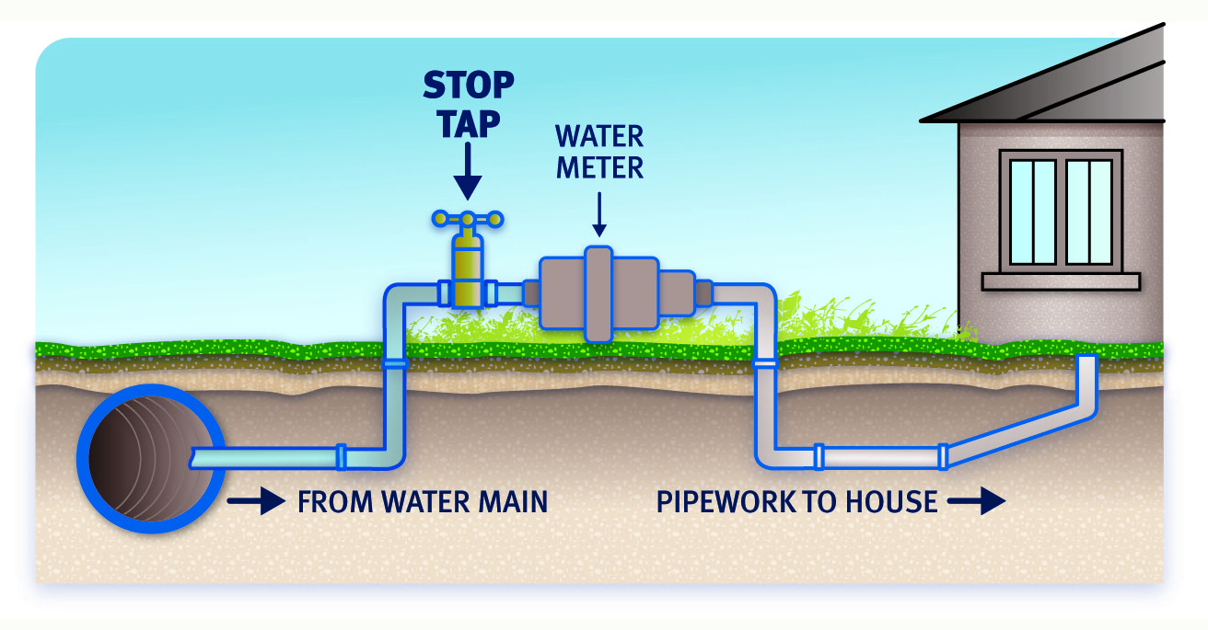

What to do before the interruption
If possible Please TURN OFF your stop tap at the water meter prior to the time indicated, (see diagram above). This may prevent any discoloured water from entering the pipes.

If you are unable to turn the stop tap off, simply don’t use any water during the times specified.

During the interruption
DO NOT operate any tap or appliances that use water between the hours stated on this notice. If one is turned on by accident DO NOT leave it turned on or operational.

What do I do when the water is restored?
Turn the stop tap back on and run the furthest tap from your meter until the water is clear. Then run a small quantity of water from all taps on your property until there is a continuous clear flow from each one. Do not use a household appliance that uses water until the water is running clear and free from air.

We apologise for any inconvenience, and thank you for your cooperation.

